¡Hi¡ Thank you for downloading this rig.

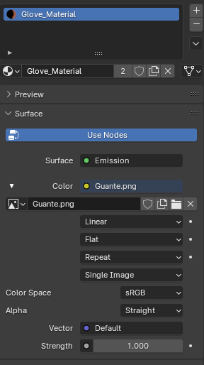This cartoon style boxer character, all the materials must be set on the emission surface and you must insert the corresponding texture.

This rig has drivers for a 2D facial rig. For the rig to work you must do the following:

1. 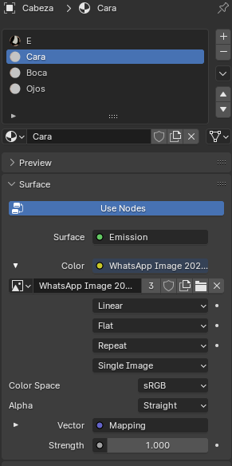Assigns the texture called "eyes and mouth" to the materials called “Ojos”,”Boca”

Spanish Glossary

Eyes = Ojos

Mouth = Boca

Face = Cara

1. There are two bones that are responsible for changing the character's facial expressions, one for the mouth and one for the eyes. You just have to move the bones on the Z axis to change the expressions.

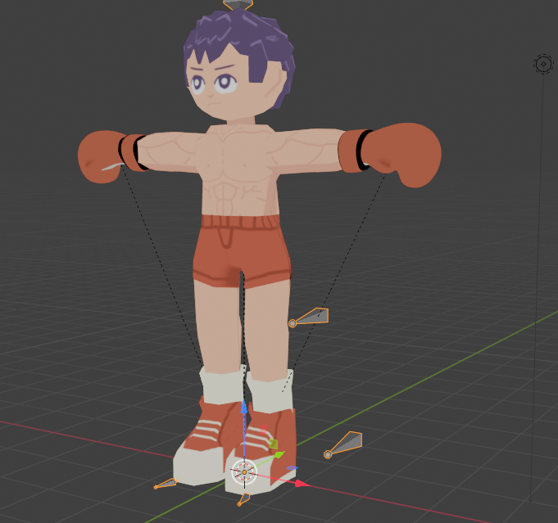

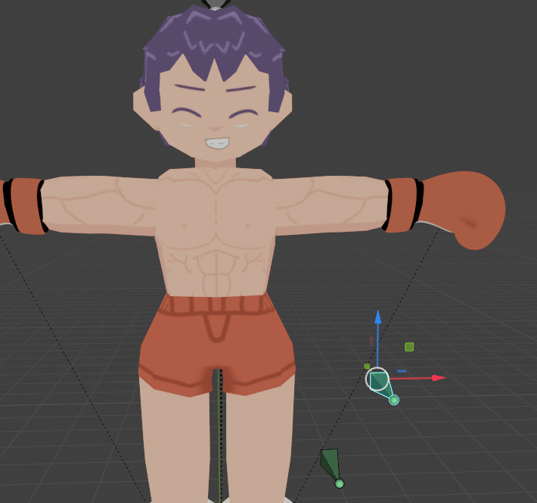

Example of one of the character's expressions:

However, for the controllers to work on the mouth and eyes material you must use these nodes:

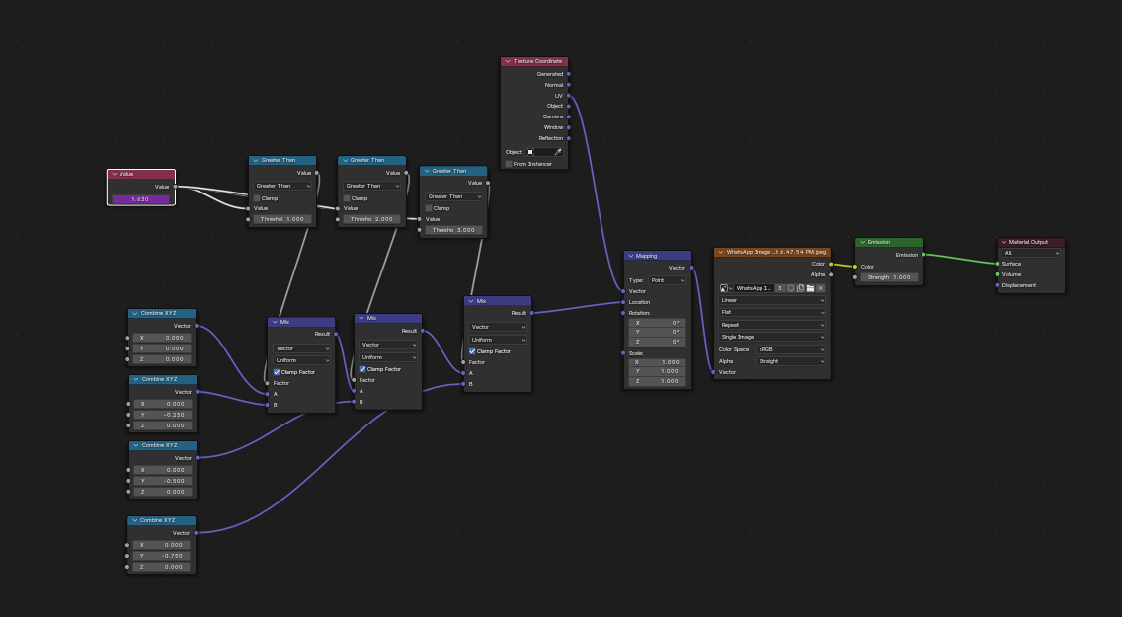

Watch the following video to learn how to use the facial controllers, The video was created by lacruzo:

https://www.youtube.com/watch?v=E96m9Z4iTcc